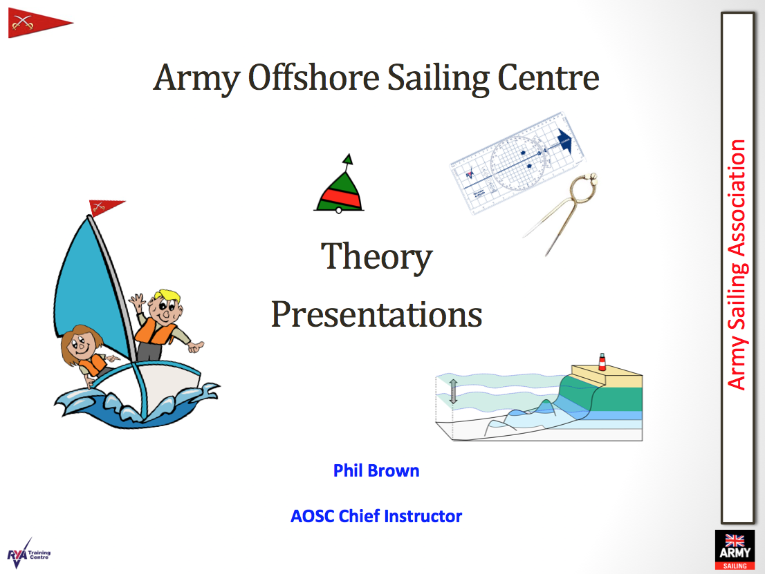

The Army Offshore Sailing Centre will be hosting a number of Virtual Theory Presentations over the coming weeks, by the use of Zoom.

Starting on 02 March 2021, the presentations will be held each Tuesday evening from 1900 hrs and will last for approximately 45 mins to an hour.

The presentations, will include a variety of subjects, from buoyage to chartwork, from stability to navigating in restricted visibility, are free of charge and will finish with an opportunity for anyone to ask any relevant questions.

To access the presentations, download the zoom app and use the following codes to join the meeting.

Meeting ID: 216 640 9807
Passcode: 555238

Everyone is welcome to listen in, so make sure you don't miss out. Come and join us for an hour of revision and a chance to meet other ASA members… And don't forget your glass of wine.

